1: Create Tomcat Container on Port 8080 + Deploy App

Step 1: Pull Tomcat Image
docker pull tomcat
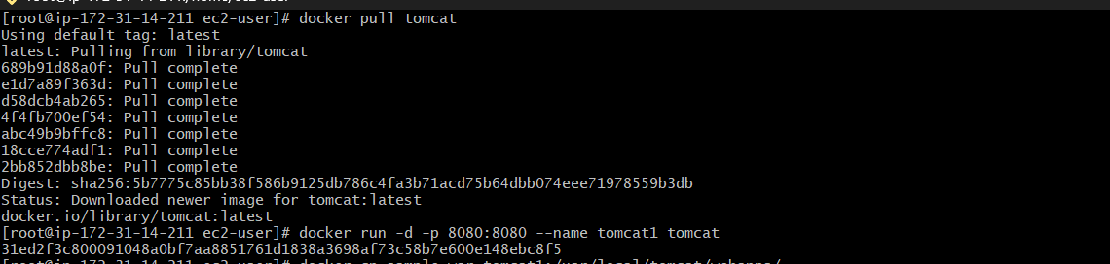
Step 2: Run Tomcat Container (Port 8080)
docker run -d -p 8080:8080 --name tomcat1 tomcat
Now access:
http://<your-ip>:8080
Step 3: Deploy Sample App
Download Sample WAR File
Run this:
wget https://tomcat.apache.org/tomcat-7.0-doc/appdev/sample/sample.war
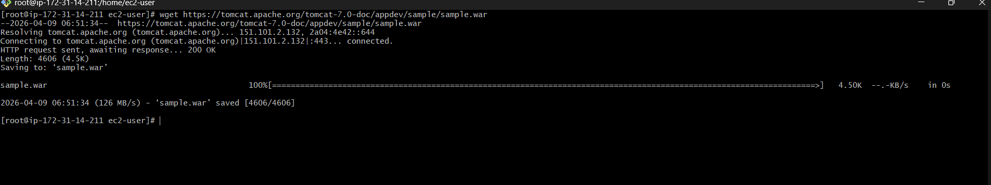
Verify File
ls -l
You should see:
sample.war
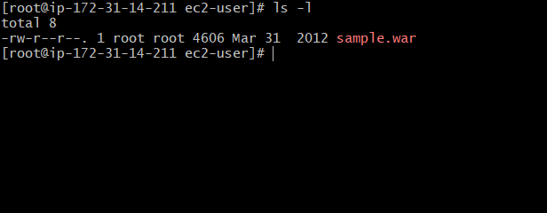

Copy into Tomcat Container
docker cp sample.war tomcat1:/usr/local/tomcat/webapps/
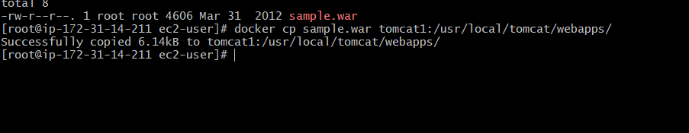

Step 4: Check Inside Container (Option
docker exec -it tomcat1 bash
cd webapps
ls
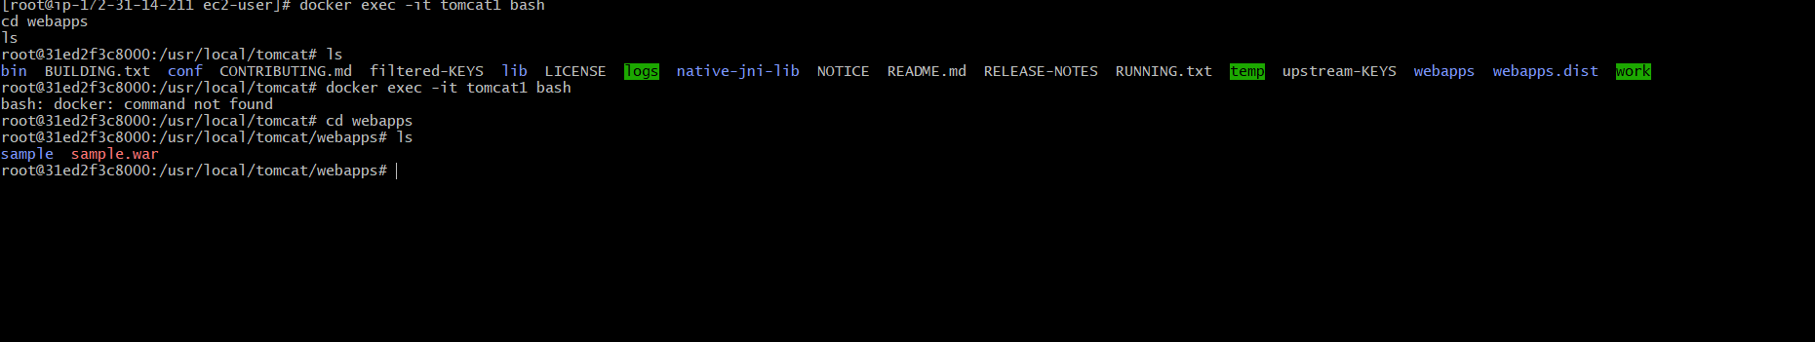
ccess Application
Open browser:
http://<your-ec2-public-ip>:8080/sample

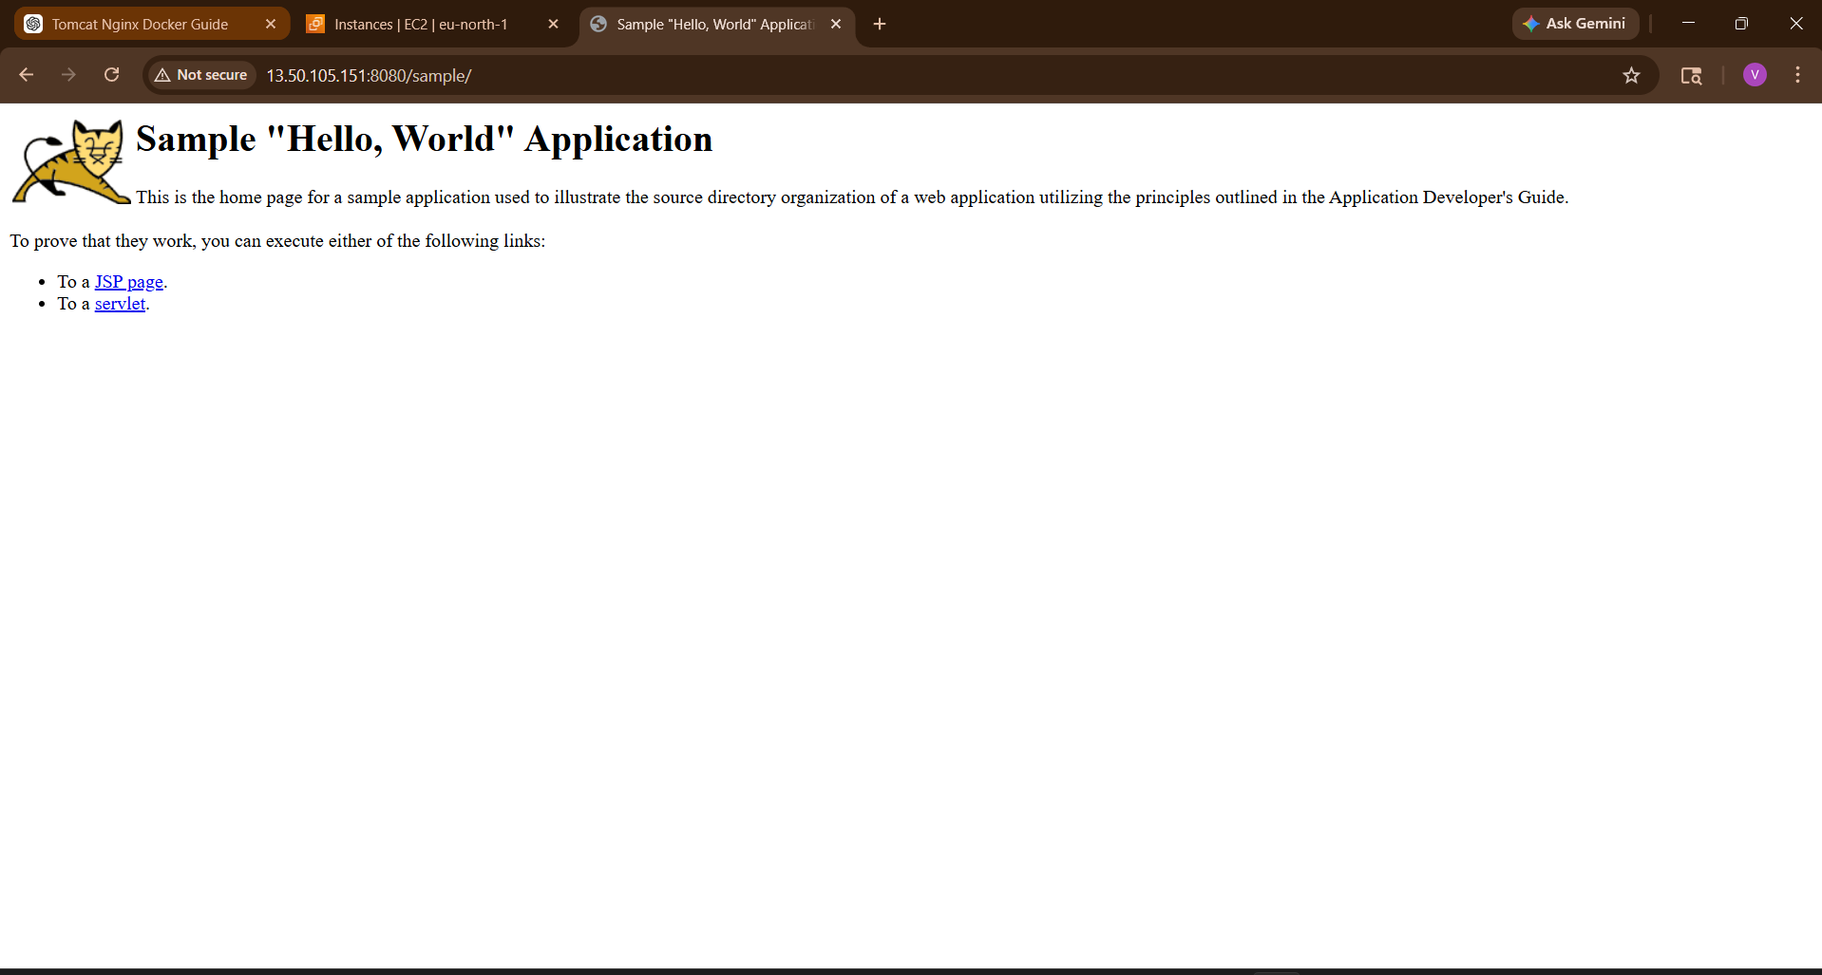

2: Tomcat with Volume + Port 8081
Step 1: Create Volume
docker volume create tomcat-data

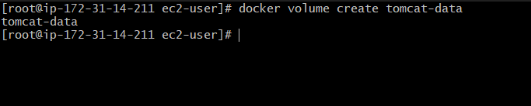
Step 2: Run Container with Volume
docker run -d \
-p 8081:8080 \
--name tomcat2 \
-v tomcat-data:/usr/local/tomcat/webapps \
tomcat
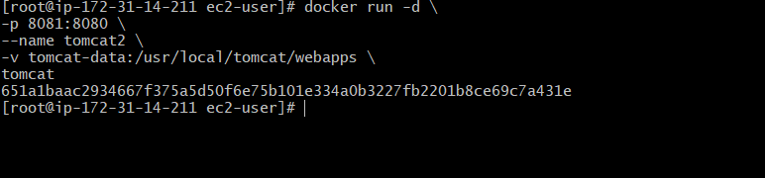
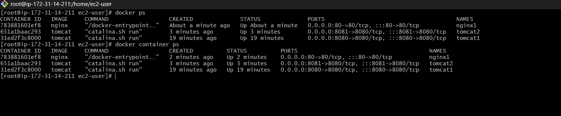
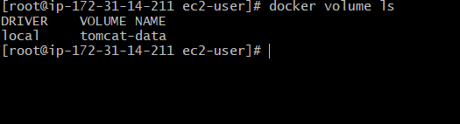

Why volume?
- Data persists even if container deleted
- Real-time app updates

3: Limit Nginx Container to 500MB
Run This Command :
docker run -d \
--name nginx1 \
-p 80:80 \
--memory="500m" \
nginx
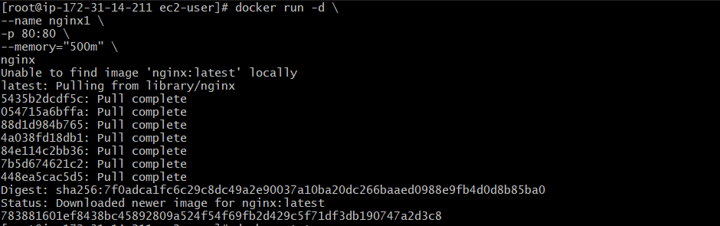
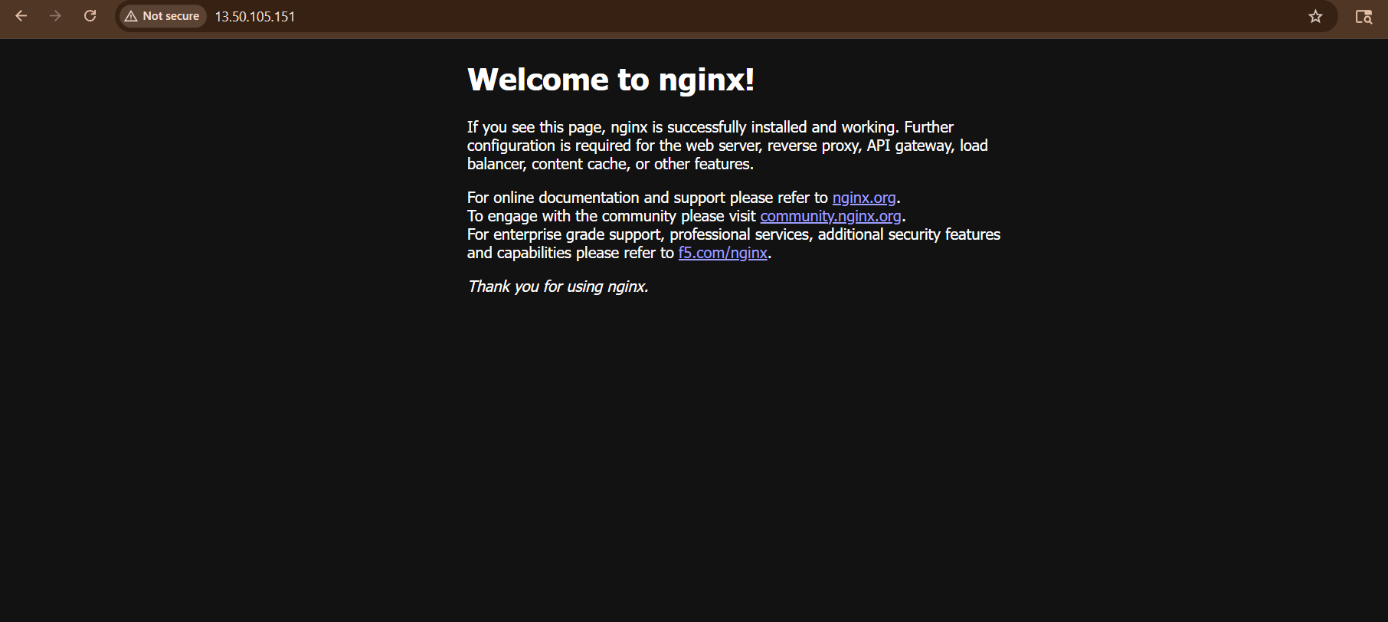
Memory limited to 500MB
Useful in production to avoid resource overuse
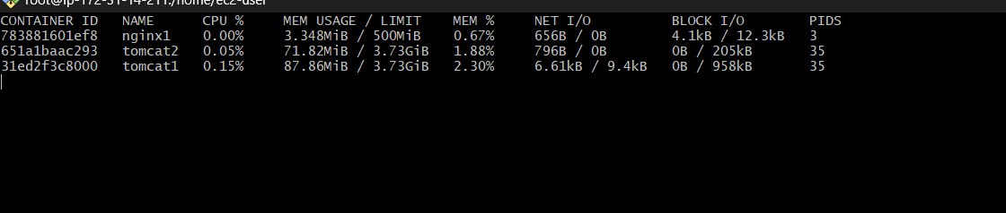

4: Create a sample docker file using below instructions.

- Base module as amazonlinux:latest
- Maintainer you name
- Install nginx
- COPY one index.html file to image
- Expose on port 80

Step 1: Create a Project Folder
mkdir nginx-project
cd nginx-project
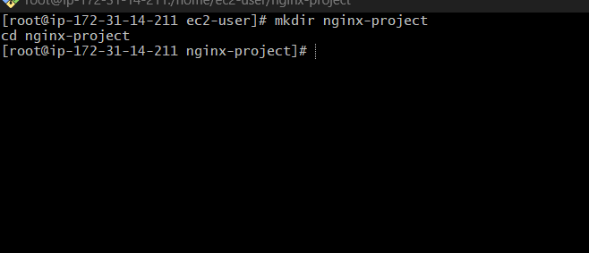
This keeps things clean (very important in real projects)
Step 2: Create Dockerfile
Run:
vi Dockerfile
Press i (insert mode) and paste this:
# 1️⃣ Base Image
FROM amazonlinux:latest
# 2️⃣ Maintainer
LABEL maintainer="vignesh"
# 3️⃣ Install nginx
RUN yum update -y && \
yum install -y nginx && \
yum clean all
# 4️⃣ Copy index.html to nginx default location
COPY index.html /usr/share/nginx/html/
# 5️⃣ Expose port 80
EXPOSE 80
# 6️⃣ Start nginx
CMD ["nginx", "-g", "daemon off;"]

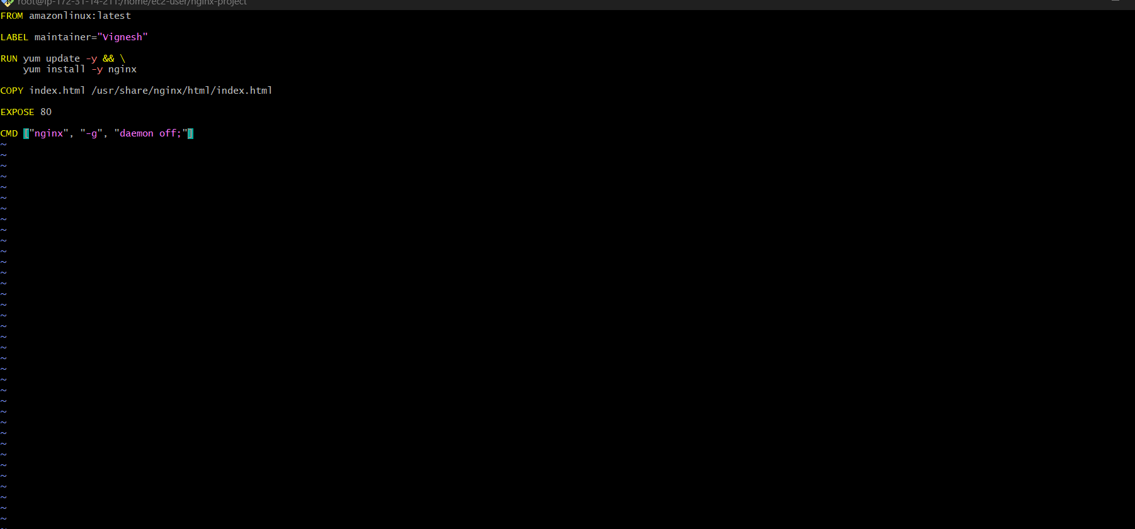

Press:
- Esc
- type :wq
- press Enter (save & exit)
Step 3: Create index.html
vi index.html
Press i and add:
HTML
<!DOCTYPE html>
<html lang="en">
<head>
<meta charset="UTF-8">
<meta name="viewport" content="width=device-width, initial-scale=1.0">
<title>My Nginx App</title>
<style>
body {
background: linear-gradient(135deg, #1e3c72, #2a5298);
font-family: Arial, sans-serif;
color: white;
text-align: center;
padding-top: 100px;
}
h1 {
font-size: 40px;
animation: fadeIn 2s ease-in-out;
p {
font-size: 20px;
margin-top: 20px;
}
button {
padding: 10px 20px;
font-size: 16px;
background: orange;
border: none;
cursor: pointer;
border-radius: 5px;
}
button:hover {
background: red;
color: white;
}
@keyframes fadeIn {
from { opacity: 0; }
to { opacity: 1; }
}
</style>
</head>
<body>
<h1 id="title">Loading...</h1>
<p id="time"></p>
<button onclick="changeMessage()">Click Me 🚀</button
<script>
// Dynamic text on load
document.getElementById("title").innerText =
"Welcome to My Nginx App 🚀 FROM VIGNESH"
// Show current time
function updateTime() {
const now = new Date();
document.getElementById("time").innerText =
"Current Time: " + now.toLocaleTimeString();
setInterval(updateTime, 1000);
// Change message on button click
function changeMessage() {
document.getElementById("title").innerText =
"🔥 You clicked the button! DevOps + JS Power 💥";
}
</script
</body>
</html>
Save:
- Esc
- :wq

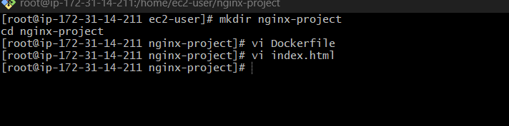
Step 4: Verify Files
Ls

Output should be:
Dockerfile
index.html
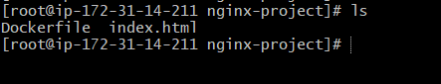

Step 5: Build Docker Image
docker build -t my-nginx .
Important:
- -t my-nginx → image name
- . → current directory (Dockerfile location)

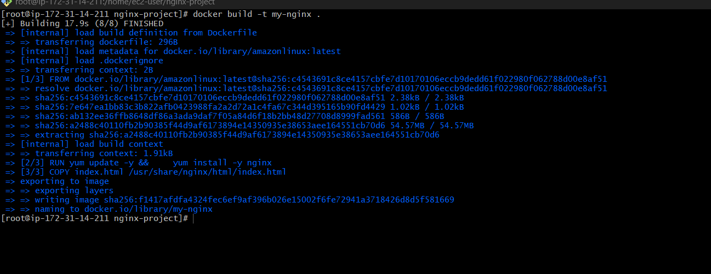

Command to start the nginx container

Step 6: Run Container
docker run -d -p 8082:80 --name nginx-container my-nginx

1️⃣ docker run
This tells Docker:
“Create and start a container”
Think:
- Image = blueprint
- Container = running app

2️⃣ -d (detached mode)
Runs container in background
✔ Terminal free
✔ Container keeps running
Without -d:
- terminal will get stuck

3️⃣ -p 8082:80 (Port Mapping)
MOST IMPORTANT
Format:
-p <host-port>:<container-port>
So here:
- 8082 → EC2 machine port
- 80 → inside container (nginx default port)
Meaning:
When you open http://<IP>:8082 → request goes to nginx (port 80 inside container)

4️⃣ --name nginx-container
Assigns a custom name
✔ Easy to manage
✔ Instead of random ID
Example:
docker stop nginx-container

5️⃣ my-nginx
This is your image name
Created using:
docker build -t my-nginx .

Access Application
Open browser:
http://<your-ec2-public-ip>:8082
You’ll see:
Welcome to My Nginx App 🚀

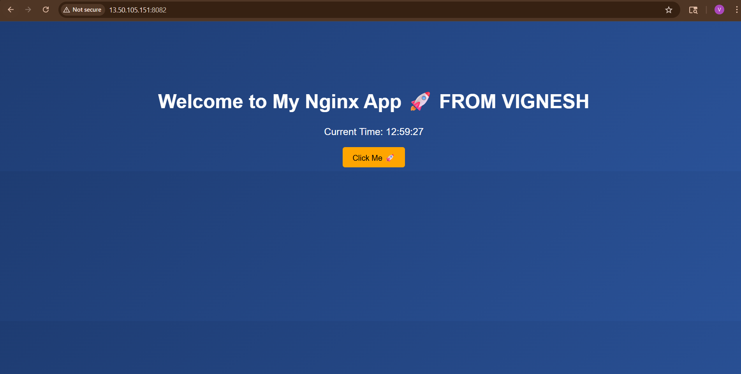
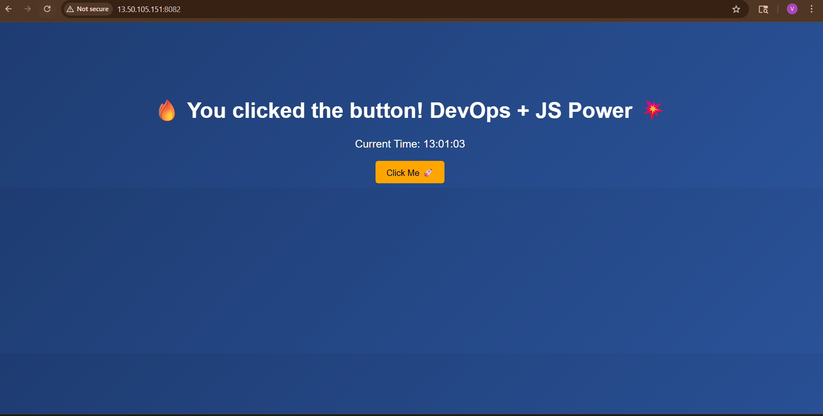

REAL-TIME ANALOGY
Think like this:
- EC2 = Apartment
- Container = Room
- Nginx = Person inside room
- Port 8082 = Door
- Port 80 = Person’s phone
When someone knocks door (8082)
It reaches person’s phone (80)

FINAL FLOW
Browser:
http://EC2-IP:8082
👇
EC2 port 8082
👇
Mapped to container port 80
👇
Nginx serves your page 🎉

Verify
docker ps
You’ll see:
- nginx-container
- port mapping 8082->80
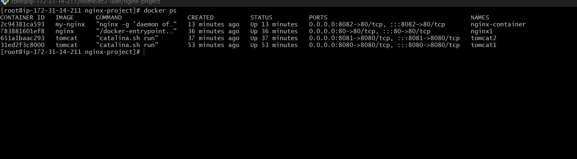

5: Push Image to Docker Hub
Step 1: Create Docker Hub Account
Go to:
➡️ Docker Hub (https://hub.docker.com)
✔ Sign up (if not already)
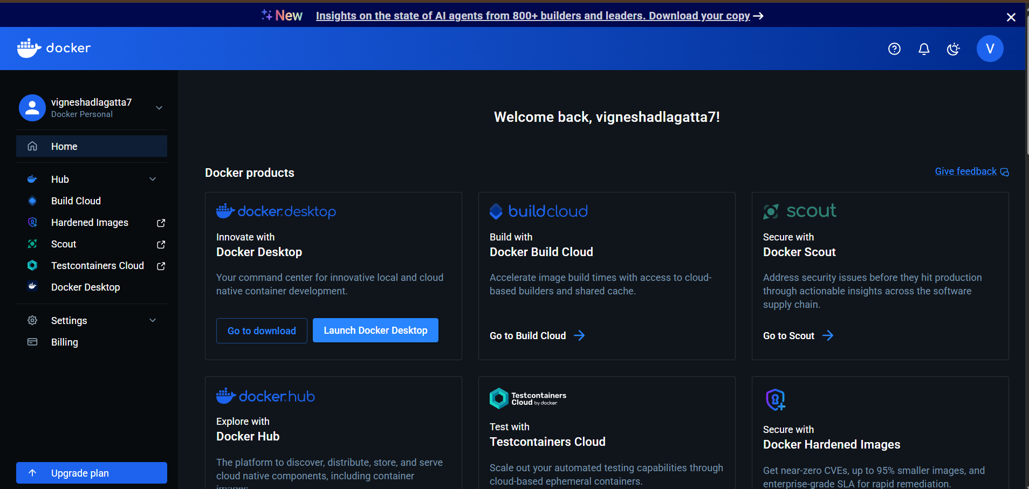

Step 2: Login from EC2
docker login
Enter:
- Username
- Password
✔ If success:
Login Succeeded
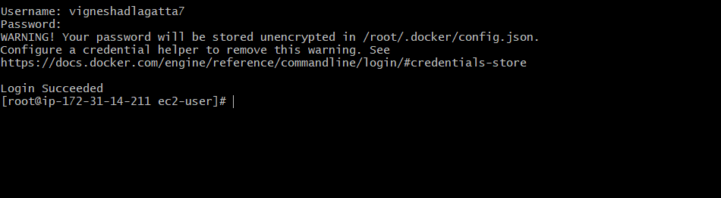
Step 3: Check Your Image
docker images
Example output:
my-nginx latest abc123
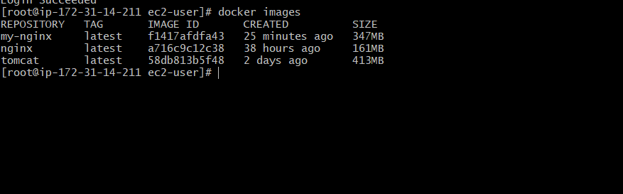
Step 4: Tag Image (VERY IMPORTANT )
Format:
docker tag <image-name> <dockerhub-username>/<image-name>
Example:
docker tag my-nginx vignesh123/my-nginx

✔ Now image is ready for Docker Hub

Step 5: Verify Tag
docker images
You’ll see:
my-nginx latest
vignesh123/my-nginx latest
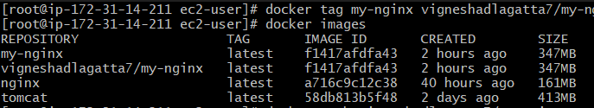

Step 6: Push Image
docker push vigneshadlagatta7/my-nginx
Output:
Pushing layers...
✔ After success:
latest: digest: sha256:xxxx

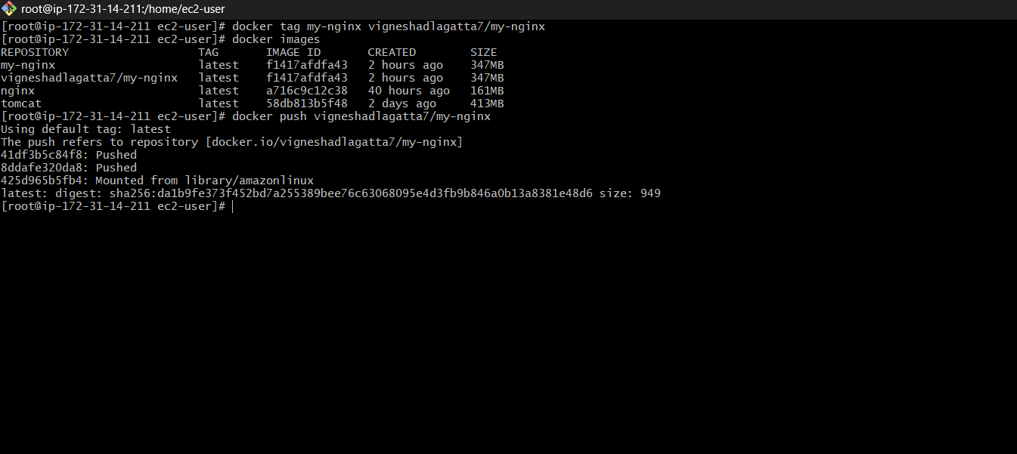

Step 7: Verify on Docker Hub
Open Docker Hub
Go to Repositories
You’ll see:
Vigneshadlagatta7/my-nginx

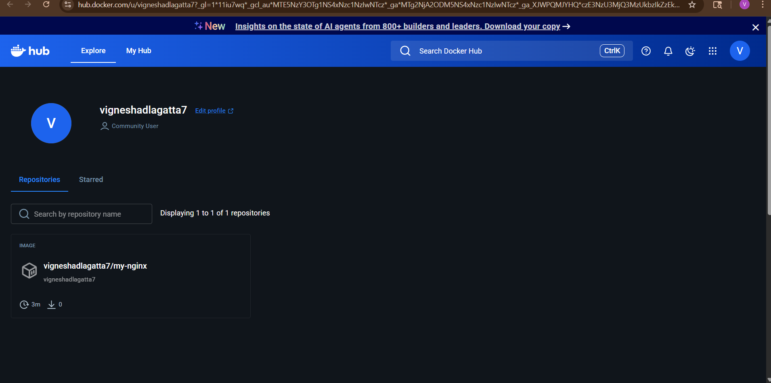
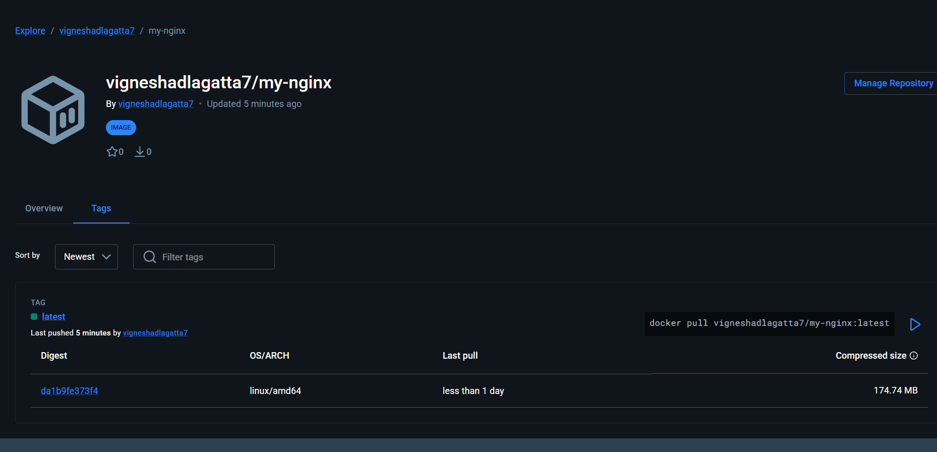
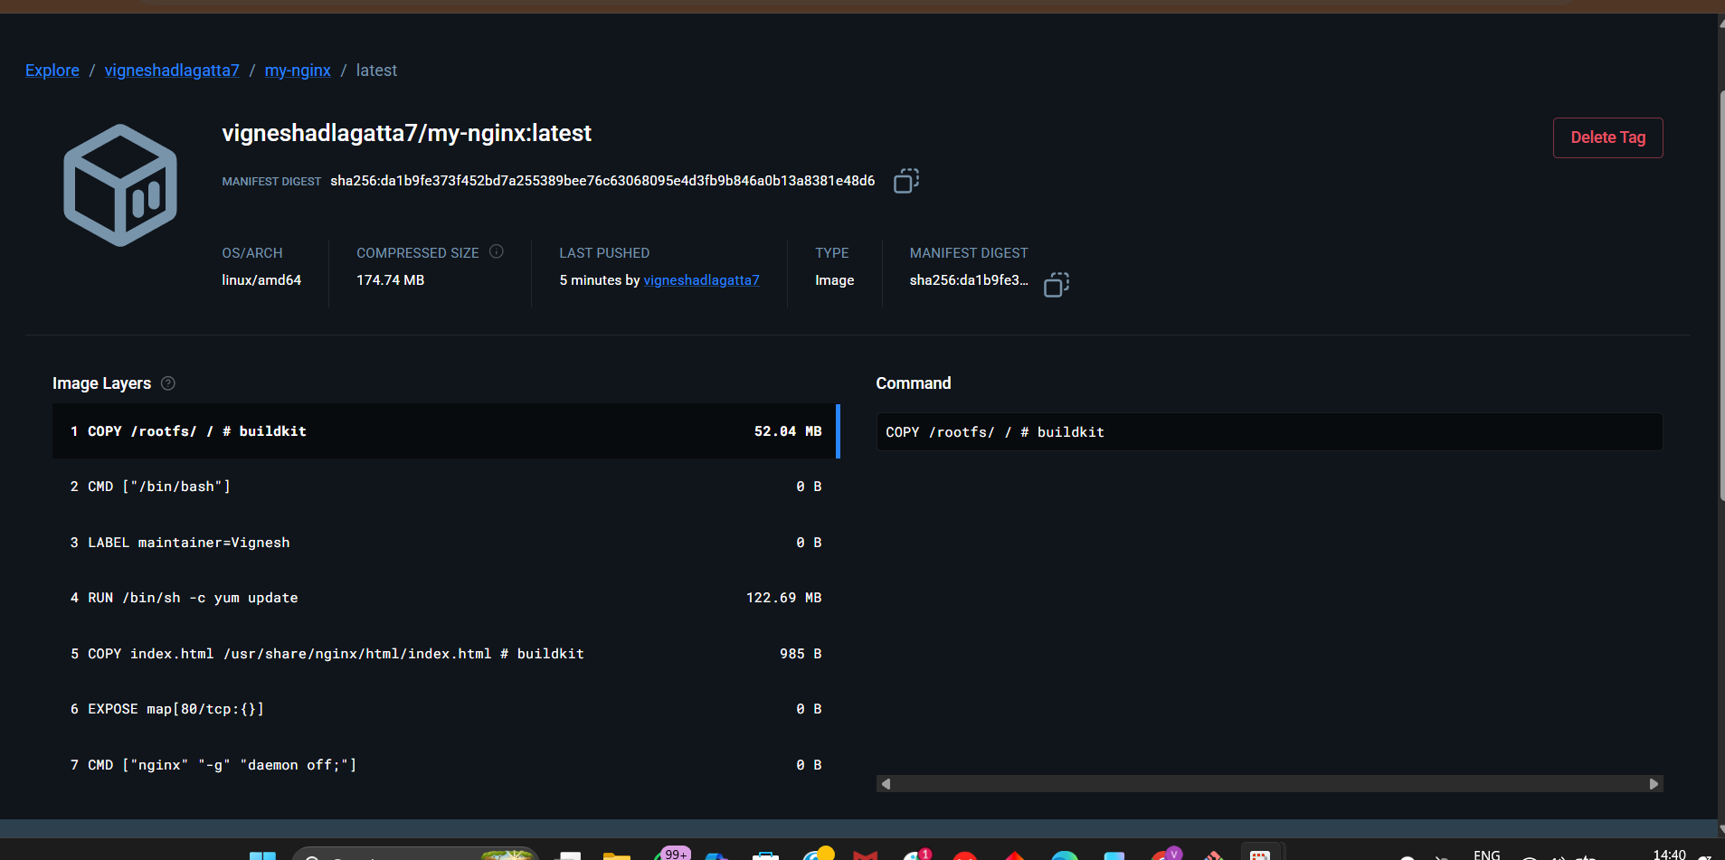

REAL-TIME UNDERSTANDING
Think like this:
- Your system = local kitchen
- Docker Hub = online food delivery app
- Push = uploading your dish

6) push image to AWS ECR
Step 1: Install & Configure AWS CLI
Install (if not installed)
sudo yum install -y aws-cli
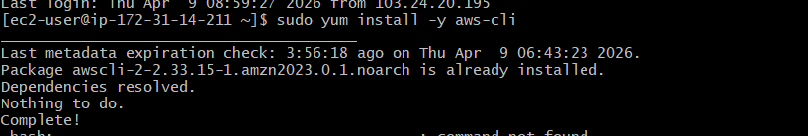

Configure AWS
aws configure

Enter:
- AWS Access Key
- AWS Secret Key
- Region → ap-south-1 (Mumbai)
- Output → json
Step 2: Create ECR Repository
aws ecr create-repository --repository-name my-nginx --region ap-south-1
Output will contain:
repositoryUri: <account-id>.dkr.ecr.ap-south-1.amazonaws.com/my-nginx
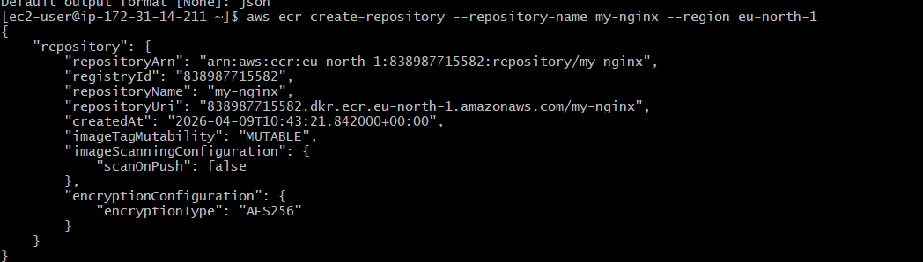
Step 3: Login to AWS ECR
aws ecr get-login-password --region eu-north-1 | \
sudo docker login --username AWS --password-stdin 838987715582.dkr.ecr.eu-north-1.amazonaws.com
Expected:
Login Succeeded
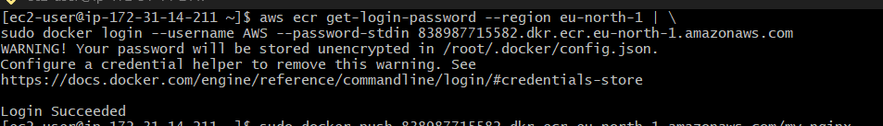
Step 4: Tag Your Image
Your local image:
my-nginx
Tag it for ECR:
docker tag my-nginx 838987715582.dkr.ecr.eu-north-1.amazonaws.com/my-nginx

Step 5: Verify Tag
docker images
You should see:
my-nginx
838987715582.dkr.ecr.eu-north-1.amazonaws.com/my-nginx
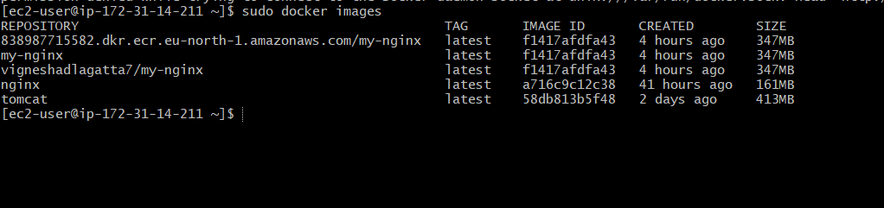
Step 6: Push Image
sudo docker push 838987715582.dkr.ecr.eu-north-1.amazonaws.com/my-nginx
Output:
Pushing layers...
✔ Done
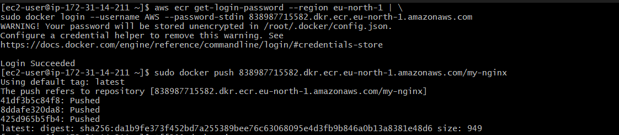
Step 7: Verify in AWS
Go to:
AWS Console → ECR → my-nginx
You’ll see your image there ✅
